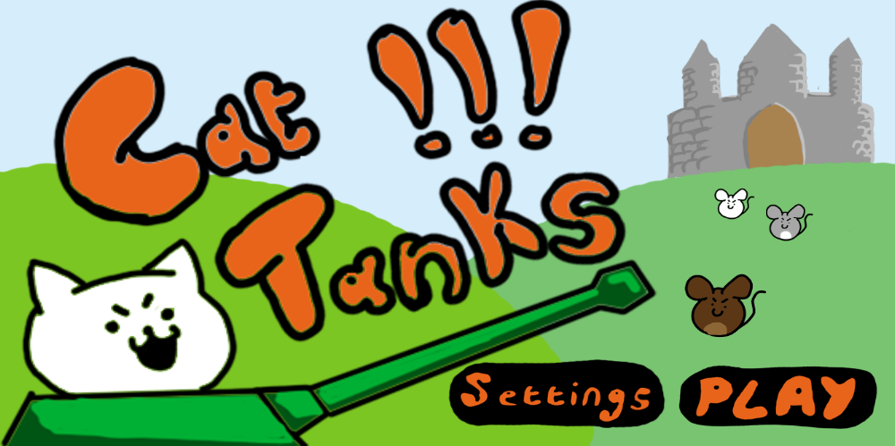Cat Tanks!

The following is Alex Linham’s proposal for a turn-based ballistics puzzle game, playable on iPhone 6 and all iPhone models produced after. This game is designed similarly to Angry birds, but with a unique approach to character interactions and a cute art style. This game is planned to be updateable with more map packs in order to maintain a larger player base.

Game design.
Overview
Cat Tanks! is a single player ballistics puzzle game with the objective of defeating the evil mice characters who have catnapped the kittens. This is achieved by using the military might of the cat tanks.
What sets this game apart is the players ability to interact with their cat tanks. The player will be able to customize aesthetics for their cat tanks by gaining rewards from playing the game. This will add a layer of player involvement not seen in similar game types. The cute art style will also make the game stand out amongst the crowd.
There are two main environments, the Battle Field (the puzzle environment, where the level takes place) and the Cat Base.
The game takes a lot of influence in art style from the app Neko Atsume : Kitty Collector. This may be referenced for inspiration. The battle fiedl will also play similarly to Angry Birds.
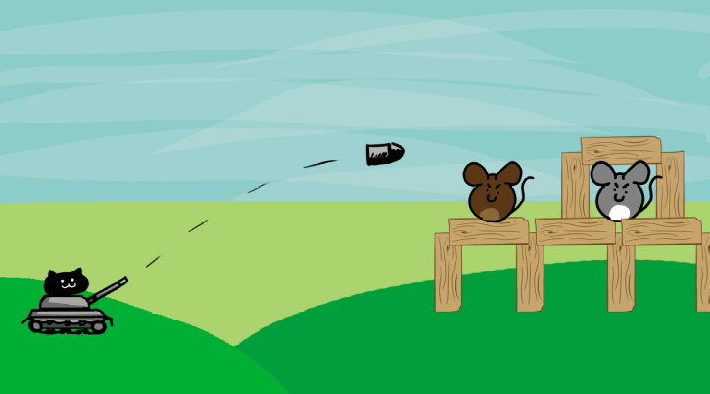 All the action in the Battle Field takes place on a side-on 2D view of the battle (see image). The game operates on a limited number of turns, and the player must use their finger to aim the direction of their shot, then also tap the screen to select the shots power. The cat tanks remain stationary in the level, and the win condition is met if the player successfully destroys the mice characters within the limited number of moves. Environment design and the placement of destructible objects (such as the wood) increase the difficulty of the levels. The unique character abilities allow for Several solutions to one levels’ win condition.
There are 7 controllable and customizable cat tanks at the players disposal. They have unique abilities that are discussed later in the document, and upon completing levels, the player is rewarded with the saved kittens. These kittens can be used to unlock aesthetic accessories for your cat tanks, which can be equipped in the Cat Base.
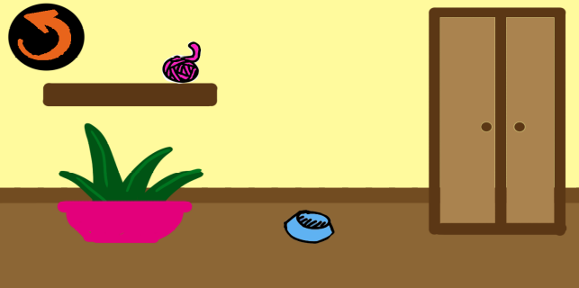The Cat Base acts as a level hub for selecting which level is to be played, but also allows the player to access each Cat Tanks own unique Room, or the workshop. The Workshop is where the player can use kittens to build desired objects, such as a pair of sunglasses or a ball of yarn. The kittens work like single use currency. The Cat Tanks rooms are small environments where the player can customise the aesthetics. For example, a player may equip a new tanks skin for the tank or place a pot of catnip in the rooms corner and a feather on the shelf. The purpose of the customisation is purely aesthetic, there is no advantage to owning these items. However, the player will feel more immersed in the world if they are able to interact with the cat tanks in a more personal way. Tapping the wardrobe allows access to the different tank skins, and allows the player to place objects in the room. The directional arrow will take the player back to the previous menu. Showing the cats interreacting with the toys would add depth to the game, much like in Neko Atsume.
The levels will have replay value, as completing the level rewards you with the maximum amount of kittens, but the player can replay the level for less reward in order to save up and buy more objects for their Cat Tanks.
The sound design should focus on a fun, light theme. Instruments such as the kazoo and the recorder may be used to invoke a playful and childish theme.
Plot and Settings
The cats have always been at war with the mice, as the mice steal the cat’s food. But this time, the mice have gone too far, and they cat napped the kittens! The mice are demanding even more food, and worse still, the ransom for the kittens is all the precious milk and cream for the greedy mice to fuel their cheese addiction. Enough is enough! The cats use their latest in military technology to wage war against these trouble making mice.
The world of cat tanks is a cartoon fantasy, and the player appears in the game as the commander of the cat tanks, here to guide them to victory. The games tone is light and cheerful, reminiscent of adventure time and other cartoon shows of a similar nature.
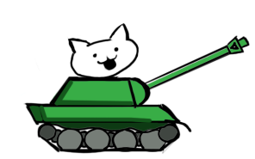The aesthetic themes from the workshop will be themed upon the cats and their personalities. Common items can be enjoyed by all cats, for example, a ball of yarn or a can of cat food. But certain cats have unique items. For example, Robocats favourite food is a battery and one of his favourite and unique items is a skin that makes his futuristic tank look like it is from a steampunk genre.
Purrrman is the all-American cat with a Sherman tank. A patriotic cat who loves his home food and flags almost as much as he hates the evil mice. No special tank abilities, but is the embodiment and lead figure of the Cat Tanks.
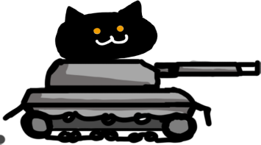
Panzer is a cat who likes to get the job done quickly and quietly. An assassin cat, black as shadow, who launches small but fast projectiles. Her orange eyes glow with a burning passion for revenge on the mice. She drives a panzer tank.

Tiger will rain down glorious lead fury upon his opponents. His ginger tabby fur is respectable and enviable, and he has a taste for Chinese goods. He is cool and confident in the fact that his projectiles, whilst slow, will deal a satisfying amount of damage. He drives a Tiger tank.
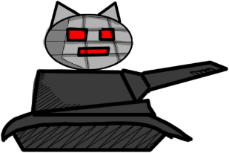
Mecha cat has come from the future to aid the Cat Tanks. He is equipped with all the latest technology, and will use his cybernetically enhanced body and tank to fire lasers at his foes. His computing mind sees the most efficient path to victory, but he is a soft robotic kitten at heart, who loves his sci-fi. The lasers are not affected by gravity

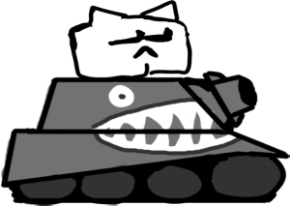Man cat has it all. The chiselled chin. The shades. The clean white fur. Previously bullied for being called snowball, man cat carved the essence of cool into his physique to show those bullies what’s what. He’s now so confident that he launches himself from the Sturmtiger tank to throw himself about in an explosive manner. He loves the gym, and his macho idols like Rambo and John Cena.

The prrrincess. Always adored as a beautiful figure in the cat’s public eye, but she has a real mean streak. Her public image shows a fragile, girly princess, but she is sadistic kitty who adores the punk scene. Spikes and dark eyeliner are two of her favourite things but being cute is also a priority. Palas cat looks. Her spiked projectiles look like flying morning stars, and they do little damage to objects, but massive damage to soft enemies.

Martyn is the unique Tank Cat. Yes, this cat launches tanks. He is large, and this allows him to eat tanks. He can vomit small tanks as if they were metallic hairballs. Slow projectiles that are very damaging. Martyn’s military training saw him use a tank for the first time. However, Martyn got bored of using the tank conventionally, and saw much more logic in throwing a tank sized projectile at the enemy. Martyn is styled off our group project lecturer, Martyn Simmons, and will therefore need colour patches on his fur to match Martyn’s’ beard.

Gameplay

A walkthrough of one level goes like this.
After starting up the game, the player is greeted by the cat tanks logo and the main menu screen, where you can select to play the game or edit settings in a settings menu. On selecting the play game button, the player is taken to the cat base. There are clickable options to explore the cat tanks’ rooms, visit the workshop, or go to the level select screen.
On clicking the level select screen, the player is taken to a list of levels that they currently have access to. On selecting a level and hitting a play button, the player is taken to the level of choice. Once the level is loaded, the player will see a zoomed out view, showing the location and environment of the enemies. The camera then focuses on the cat tanks, which the player can control. The player must correctly launch their projectiles from their tanks to beat the level.
If the player succeeds in destroying the mice, they are greeted with a victory screen and rewarded with kittens. The player can then return to the Cat Base and select the Workshop. They can use the kittens they just earnt and build a new item, for example, a ball of yarn. Then they can return to the Cat base, select the cat’s rooms, and select an area in the room to place their newly created object.
All menu systems should be designed with simplicity in mind, as this game will be appealing to all age groups, and so, needs to be easily readable and recognisable. The more accessible our game becomes, the more successful it will become.

Development.
The game is designed for the iPhone 6 and all later iPhone models. Below are some specifications of the iPhone 6.
Type | LED-backlit IPS LCD, capacitive touchscreen, 16M colors
Size | 4.7 inches, 60.9 cm² (~65.8% screen-to-body ratio)
Resolution | 750 x 1334 pixels, 16:9 ratio (~326 ppi density)
Multitouch | Yes
OS | iOS 8, upgradable to iOS 12.1
Chipset | Apple A8 (20 nm)
CPU | Dual-core 1.4 GHz Typhoon (ARM v8-based)
GPU | PowerVR GX6450 (quad-core graphics

We plan to spend half a year to develop one level of this game. We will need two programmers and two artists as a minimum. The playable level is key in production, but well-crafted menu systems would be key for fleshing out the game.
Cat Tanks! Will be an art intensive game, and the aesthetics should be a main focus in production. The game will have a side on 2d view.
We plan to use software such as photoshop and unity to create the art pieces and the game.

Marketing
The game shares similarities with popular games, such as Angry Birds, however, the independent art style and interaction with the Cat Tanks allow the game to be an instantaneously recognisable and unique entity.
The games unique selling point is the ability of the player to interact with their cat tanks in-between battles. Highlighting the customizable aspects of this game will promote a new aspect of this genre that will appeal be uniquely appealing.
The game is free to play, but it has advertising space on certain screens. The player will have the option to pay for the removal of these adverts.
If the game gains popularity, we can aim to produce a new “world” of maps every month to keep the players active on the app.

References
Hit-Point “Neko Atsume : Kitty Collector” (20 October 2014) http://nekoatsume.com/en/ (last accessed 24.12.18)
Rovio Entertainment “Angry Birds” (December 11, 2009) https://www.angrybirds.com/games/ (last accessed 24.12.18)

